PIZZA SALES SQL QUERIES
- KPI’S

- Total revenue
select sum(total_price) as total_revenue
from `sales dashboard excel file` ;
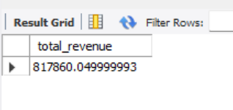
- Average order value
SELECT sum(TOTAL_PRICE)/count(DISTINCT ORDER_ID) AS AVG_ORDER_VALUE
from`sales dashboard excel file`;
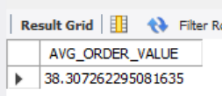
- Total pizza sold
select sum(quantity) as total_pizza_sold
from `sales dashboard excel file` ;
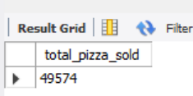
- Total orders
select sum(quantity) as total_pizza_sold
from `sales dashboard excel file` ;
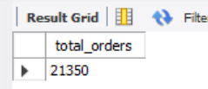
- Average pizzas per order
select sum(quantity)/ count(distinct order_id) as avg_pizzas_per_order
from `sales dashboard excel file` ;
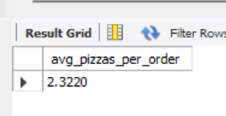

- CHARTS

- Daily trend for total orders
SELECT DAYNAME(STR_TO_DATE(order_date, '%Y-%m-%d')) AS order_day,
COUNT(DISTINCT order_id) AS total_orders
FROM `sales dashboard excel file`
GROUP BY order_day
ORDER BY total_orders ;
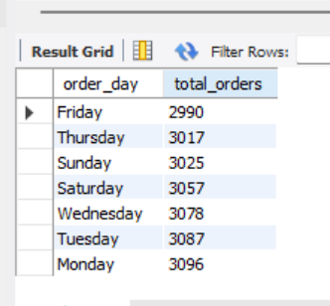

- Monthly trend for total orders

select monthname(STR_TO_DATE(order_date, '%Y-%m-%d')) as month_name, count(distinct order_id) as total_orders
from`sales dashboard excel file`
group by monthname(STR_TO_DATE(order_date, '%Y-%m-%d'));
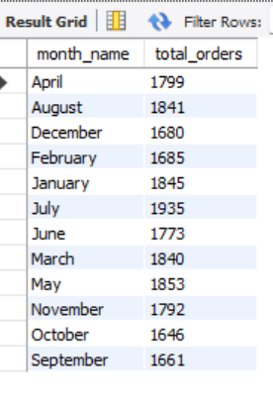
- Percentage of sales by pizza category

SELECT
pizza_category,
SUM(total_price) as total_sales, sum(total_price)*100 /(select sum( total_price)FROM `sales dashboard excel file`) as PCT
from `sales dashboard excel file`
group by pizza_category ;
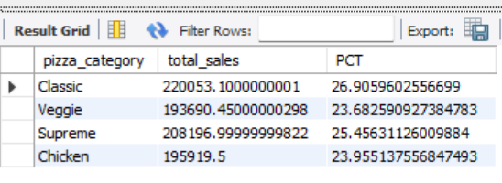
- Percentage of sales by pizza size

SELECT
pizza_size,
SUM(total_price) as total_sales, sum(total_price)*100 /(select sum( total_price)FROM `sales dashboard excel file`) as PCT
from `sales dashboard excel file`
group by pizza_size;
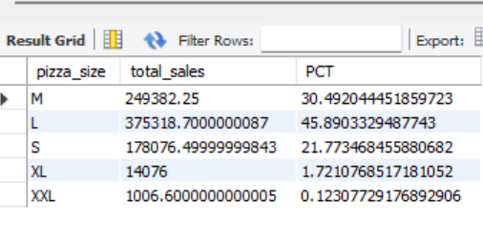

- TOP 5 pizzas by revenue
select
pizza_name , sum(total_price) as total_revenue
from `sales dashboard excel file`
group by pizza_name
ORDER BY total_revenue DESC
LIMIT 5;
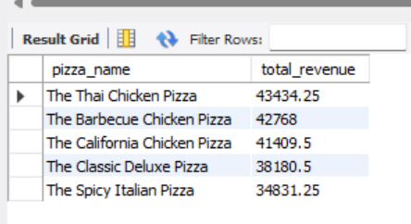

- Bottom 5 pizzas by revenue
Select
pizza_name , sum(total_price) as total_revenue
from `sales dashboard excel file`
group by pizza_name
ORDER BY total_revenue ASC
LIMIT 5;

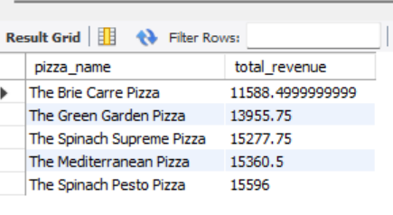
- Top 5 pizzas by quantity
Select
pizza_name , count( distinct order_id ) as total_order
from `sales dashboard excel file`
group by pizza_name
ORDER BY total_order desc
limit 5;
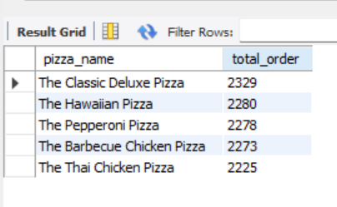
- Total pizzas sold by pizza category

Select
pizza_category, sum(quantity) as total_quantity_sold
from `sales dashboard excel file`
where month(STR_TO_DATE(order_date,'%Y-%m-%d')) = 2
group by pizza_category
order by total_quantity_sold desc;
